Electricity - 09
CLASS 10 - SCIENCE

 | Section A
1 | In what way household appliances should be connected? | [2]
2 | A student has connected abattery of 12V in a series combination of resistors 3$Ω$ , 4 $Ω$ , 5 $Ω$ and 12 $Ω$ . How much current would flow through the 12 $Ω$ resistor. | [2]
3 | Suppose the ammeter (or voltmeter) you are using in verifying ohm’s law experiment does not have positive (+) and negative ( - ) terminal markings, how will you use such ammeter (or voltmeter) in the circuit? | [2]
4 | While experimentally verifying ohm’s law a student observed that pointer of the voltmeter coincide with 15$​^{th}$ division when the voltmeter has a least count of 0.05 V. Find the observed reading of voltmeter. | [2]
5 | If two resistors of value R are connected in series and then in parallel, what is the difference in equivalent resistance in both cases? | [2]
6 | The values of current I flowing in a given resistor for the corresponding values of potential difference V across the resistor are given below - 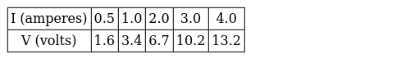  Plot a graph between V and I and calculate the resistance of thatresistor. | [2]
7 | A student performed Ohm’s law experiment, in which observed that the deflection on ammeter (or voltmeter) scale goes beyond the full scale. What will you infer from such an observation? What will you infer if the deflection takes place in opposite direction? | [2]
8 | In an experiment, a student connected two conducting wires of same material, equal length and equal diameter in series. How does the heat produced by the combination of resistors change? | [2]
9 | Mention the condition under which charges can move in a conductor. Name the device which is used to maintain this condition in an electric circuit. | [2]
10 | If the resistor of a known resistance value is replaced with a nichrome wire of say 10 cm length in ohm’s law experiment, how do the values of current through the nichrome wire and potential difference across the two ends of it change? How the values will change if the replaced wire is of manganin in place of nichrome? | [2]
11 | Draw a schematic diagram for a circuit inwhich three resistors R$​_{1}$ , R $​_{2}$ and R $​_{3}$ ,plug key, an ammeter are joined in series with a 5V battery. Also, a voltmeter is connected to measure the potential difference across the resistor R $​_{1}$ . | [2]
12 | An ammeter has a range of 0 - 3 ampere and there are 30 divisions on its scale. Calculate the least count of the ammeter. | [2]
13 | A student has three resistors of resistance of each 2$Ω$ . But he wants to connect the 6 $Ω$ resistor.How will he connect a given set of resistors so that the equivalent resistance is 6 $Ω$ ? | [2]
14 | Explain how we connect an ammeter and a voltmeter in a circuit while performing experiment for studying the dependence of current (I) on potential difference (V) across a resistor. | [2]
15 | A wire of resistance R is cut into five equal parts. These parts are then connected in parallel. Ifthe equivalent resistance of this combination is R’. Calculate the ratio of$\frac{R}{R′}$ | [2]
 | Section B
16 | Match the following: 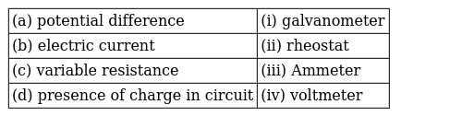 | [2]
17 | Match thefollowing: 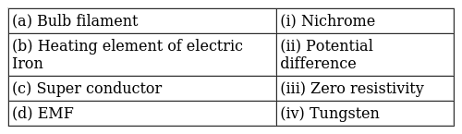 | [2]
18 | Match the following: 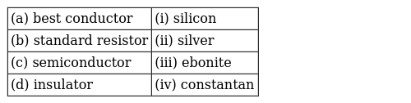 | [2]
19 | Match the following: 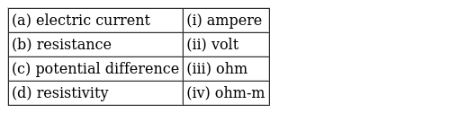 | [2]
 | Section C
20 | Two wires A and B are of equal length, different cross sectional areas and made of the same metal.(a) (i) Name the property which is same for both the wires, (ii) Name the property which is different for both the wires. (b) If the resistance of wire A is four times the resistance of wire B, calculate (i) The ratio of the cross sectional areas of the wires and (ii) The ratio of the radii of the wire. | [5]
21 | Redraw the circuit putting in an ammeter to measure the current through the resistors and a voltmeter to measure the potential difference across the 12$Ω$ resistor. What would be the readings in the ammeter and the voltmeter? | [5]
22 | - State Ohm’s Law.  - Name and define the physical quantity determined by the slope of V - I curve given in the diagram. Use this graph to find the value of this physical quantity in SI units. 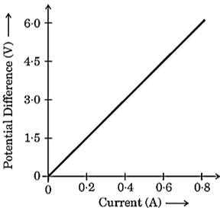  - Establish the relationship between 1 kWh and 1 joule. | [5]
23 | An electric lamp of resistance 20$Ω$ and a conductor of resistance 4 $Ω$ are connected to a 6 V battery as shown in the circuit. Calculate :  - the total resistance of the circuit,  - the current through the circuit,  - the potential difference across the(i) electric lamp and (ii) conductor, and  - power of the lamp.  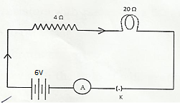 | [5]
24 | Two identical resistors, each of resistance 15$Ω$ , are connected inseriesandparallel, in turn to a battery of 6 V. Calculate the ratio of the power consumed in the combination of resistors in each case. | [5]
25 | what is electric energy ? what is its practical unit ? | [5]
26 | Three equal resistors each equal to r and connected as shown in Fig. Calculate the equivalent resistance. 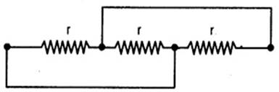 | [5]
27 | - Three resistors R$​_{1}$ , R $​_{2}$ and R $​_{3}$ are connected in parallel and the combination is connected to a battery, ammeter, voltmeter and key. Draw suitable circuit diagram and obtain an expression for the equivalent resistance of the combination of the resistors.  - Calculate the equivalent resistance of the following network: 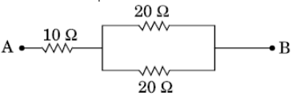 | [5]
28 | What is the resultant resistance when number of resistors are connected in parallel? | [5]
29 | - Find the ratio of resistances of two copper rods X and Y of lengths 30 cm and 10 cm respectively and having radii 2 cm and 1 cm respectively.  - A current of 500 mA flows in a series circuit containing an electric lamp and a conductor of 10$Ω$ when connected to 6 V battery. Find the resistance of the electric lamp. | [5]
30 | Three resistors are connected as shown in Fig. Through a resistor of 5 ohms; a current of 1A is flowing.  - what is the current through the other two resistors?  - what is the potential difference (P.D.) across AB and AC?  - what is the total resistance? 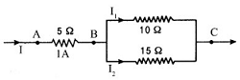 | [5]
31 | Derive the relation$\frac{1}{R}=\frac{1}{R_{1}}+\frac{1}{R_{2}}+\frac{1}{R_{3}}$ ,when resistors are joined in parallel. | [5]
32 | What is the electrical resistivity of a material? What is its unit? Describe an experiment to study the factors on which the resistance of conducting wire depends. | [5]
33 | - With the help of a suitable circuit diagram prove that the reciprocal of the equivalent resistance of a group of resistances joined in parallel is equal to the sum of the reciprocals of the individual resistances.  - In an electric circuit two resistors of 12$Ω$ each are joined in parallel to a 6 V battery. Find the current drawn from the battery. | [5]
34 | What is the potential difference between two points in the electric field ? Name and define its SI unit. | [5]
35 | What is meant by resistance of a conductor? Name and define its SI unit. List the factors on Which the resistance of a wire affected, if (i) its length is doubled, (ii) its radius is doubled? | [5]
36 | Find out the following in the electric circuit given in Figure 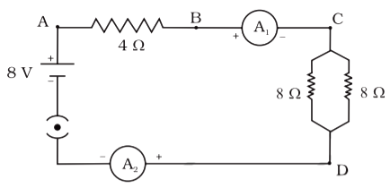  - The effective resistance of two 8$Ω$ resistors in the combination  - Current flowing through 4$Ω$ resistor  - The potential difference across 4$Ω$ resistance  - The power dissipated in 4$Ω$ resistor  - The difference in ammeter readings, if any. | [5]
37 | - Write the relation between resistance and electrical resistivity of the material of a conductor in the shape of a cylinder of length I and area of cross - section A . Hence derive the S.I. unit of electrical resistivity.  - The resistance of a metal wire of length 5 m is 100$Ω$ . If the area of cross - section of the wire is 3 $×$ 10 $​^{−7}$ m $​^{2}$ , calculate the resistivity of the metal. | [5]
38 | If three resistors each of 3 ohm are connected together in different ways. What are the possible values of resistances which can be got by combining all these? | [5]
39 | - Define electric power and state its SI unit. The commercial unit of electrical energy is known as unit. Write the relation between this unit and joule.  - In a house, 2 bulbs of 50 W each are used for 6 hours daily and an electric geyser of 1 kW is used for 1 hour daily. Calculate the total energy consumed in a month of 30 days and its cost at the rate of$₹$ 8.00 per kWh. | [5]
40 | - Two lamps rated 100 W, 220 V and 10 W, 220 V are connected in parallel to 220 V supply. Calculate the total current through the circuit.  - Two resistors X and Y of resistances 2$Ω$ and 3 $Ω$ respectively are first joined in parallel and then in series. In each case the voltage supplied is 5 V.  - Draw circuit diagrams to show the combination of resistors in each case.  - Calculate the voltage across the 3$Ω$ resistor in the series combination of resistors. | [5]
41 | - For the combination of resistors shown in the following figure, find the equivalent resistance between M & N. 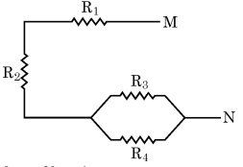  - State Joule’s law of heating.  - Why we need a 5 A fuse for an electric iron which consumes 1 kW power at 220 V?  - Why is it impracticable to connect an electric bulb and an electric heater in series? | [5]
42 | What is the need of combining different resistors? What is the resultant resistance when a number of resistances are connected in series? | [5]
43 | What is specific resistance or resistivity ? Upon what factors does it depend ? | [5]
44 | - The potential difference between two points in an electric circuit is 1 V. What does it mean? Name a device that helps to measure the potential difference across a conductor.  - Why does the connecting cord of an electric heater not glow while the heating element does?  - Electrical resistivities of silver and nicrome at 20$​^{o}$ C are 1.6 $×$ 10 $​^{−6}$ and 1.0 $×$ 10 $​^{−4}$ ,then explain why silver is used as good conductor and nicrome is used in making filaments ? | [5]
45 | Two resistances when connected in parallel give resultant value of 2$Ω$ and whenconnected in series the value becomes 9 $Ω$ .Calculate the value of each resistance. | [5]
46 | (a) Define electrical energy with the S.I. unit?(b) A household uses the following electric appliance: (i) Refrigerator of rating 400Wfor ten hours each day. (ii) Two electric fans of rating 80Weach for twelve hours each day. (iii) Six electric tubes of rating 18Weach for six hours each day. Calculate the electricity bill of the household for the month of June if the cost per unit of electric energy is | [5]
47 | In an electric circuit three bulbs of 100 W each are connected in series to a source. In another circuit set of three bulbs of the same wattage are connected in parallel to the same source.  - Will the bulb in the two circuits glow with the same brightness? Justify your answer.  - Now, let one bulb in both the circuits get fused. Will the rest of the bulbs continue to glow in each circuit? Give reason for your answer. | [5]
48 | Write three points of difference between series combination and parallel combination of resistors. | [5]
49 | - An electric iron consumes energy at a rate of 880 W when heating is at the maximum rate and 330 W when the heating is at the minimum. If the source voltage is 220 V, calculate the current and resistance in each case.  - What is heating effect of electric current?  - Find an expression for the amount of heat produced when a current passes through a resistor for some time. | [5]
50 | Current I flowing through a resistor results in dissipation of power P. By what percentage will the power dissipated in the resistor increase, if the current through the resistor is increased by 50 percent? Justify your answer with the help of mathematical calculations. | [5]
51 | Although electric kettle and electric toaster were used simultaneously in the kitchen to prepare breakfast for the family, yet the two devices could work efficiently due to fuse used in the electric circuit.  - What is a fuse? Write the material used in fuse wires. How is a fuse connected in an electric circuit?  - State the ratings of fuse used in electric circuits.  - What is the function of a fuse? How does it perform its function?  - A device uses 1 kW electric power when operated at 220 V. Calculate the rating of the fuse to be used. | [5]
52 | Derive the relation R = R$​_{1}$ + R $​_{2}$ + R $​_{3}$ , when resistors are joined in series. | [5]
53 | - Draw a labelled circuit diagram of the circuit used to show the variation of potential difference across the ends of a resistor with current flowing through it. If you use this circuit, what relation would you find between the voltmeter reading, Vand the ammeter reading, I?  - A wire of given material having length l and area of cross - section A has a resistance of 4 $Ω$ . Find the resistance of another wire of the same material having length $\frac{l}{2}$ and area of cross - section 2A. | [5]
54 | - How is electric current related to the potential difference across the terminals of a conductor?Draw a labelled circuit diagram to verify this relationship.  - Why should an ammeter have low resistance?  - Two V - I graphs A and B for series and parallel combinations of two resistors are as shown. Giving reason state which graph shows (a) series, (b) parallel combination of the resistors. 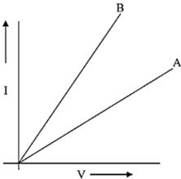 | [5]
55 | A letter ’A’ consists of a uniform wire of resistance 1 ohm cm$​^{−1}$ . The side of the letter are each 20 cm long and the cross - piece in the middle is 10 cm long while apex angle is 60 $​^{o}$ . Find the resistance of the letter between the two ends of the legs. 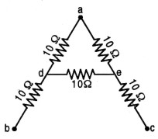 | [5]
56 | There are three resistors of 10$Ω$ , 20 $Ω$ and 30 $Ω$ joined in parallel in a circuit. The potential difference across the electric circuit is 10 V.  - Draw a circuit diagram for the above case.  - Find the total resistance of the combination of resistors.  - Calculate the electric current drawn from the same source. | [5]
57 | - Three resistors of resistances R$​_{1}$ , R $​_{2}$ and R $​_{3}$ are connected (i)in series, and (ii) in parallel. Write expressions for the equivalent resistance of the combination in each case.  - Two identical resistors of 12$Ω$ each are connected to a battery of 3V. Calculate the ratio of the power consumed by the resulting combinations with minimum resistance and maximum resistance. | [5]
58 | Obtain an expression for the heat produced in a conductor when a voltage V is applied across it. Heating effect of electric current is desirable as well as undesirable. Explain this statement. | [5]
59 | - What is meant by resistance of a conductor? Define its SI unit.  - List two factors on which the resistance of a rectangular conductor depends.  - How will the resistance of a wire be affected if its  - length is doubled, and  - radius is also doubled?Give justification for your answer. | [5]
60 | B$​_{1}$ , B $​_{2}$ , and B $​_{3}$ are three identical bulbs connected as shown in the figure. When all the three bulbs glow, a current of 3A is recorded by the ammeter A. 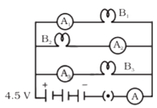  - What happens to the glow of the other two bulbs when the bulb B$​_{1}$ gets fused?  - What happens to the reading of A$​_{1}$ , A $​_{2}$ , A $​_{3}$ , and A when the bulb B $​_{2}$ gets fused?  - How much power is dissipated in the circuit when all the three bulbs glow together? | [5]
61 | Figure shows a 240 V A.C mains circuit to which a number of appliances are connected and switched on. 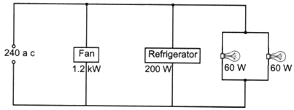  - Calculate the power supplied to the circuit.  - Calculate:  - the current through the refrigerator,  - the energy used by the fan in 3 hours,  - the resistance of the filament of one lamp. | [5]
62 | Why does electric current start flowing in a circuit the moment circuit is complete? When do we say that the potential difference across a conductor in a circuit is 1 volt? Calculate the potential difference between the two terminals of a battery if 12 joules of work is done in transferring 2 coulombs of charge. | [5]
63 | Draw a schematic diagram of a circuit consisting of a battery of 3 cells of 2 V each, a combination of three resistors of 10$Ω$ , 20 $Ω$ and 30 $Ω$ connected in parallel, a plug key and an ammeter, all connected in series. Use this circuit to find the value of the following:  - Current through each resistor  - Total current in the circuit  - Total effective resistance of the circuit | [5]
 | Section D
64 | Read the following and answer any four questions: Resistance is the property of a conductor to resist the flow of charges through it. The current which flows through a resistor is inversely proportional to its resistance, If the resistance is double the current get halves. A component of identical size that offers a higher resistance is a poor conductor.An insulatorof the same size offers even higher resistance. The resistance of the material depends on various factors. The resistivity of an alloy is generally higher than that of its constituent metal.  - The resistance of a wire of length 300m and cross - section area 1.0 mm$​^{2}$ made of material of resistivity 1.0 $×$ 10 $​^{−7}$ $Ω$ m is:  - 2$Ω$  - 3$Ω$  - 20$Ω$  - 30$Ω$  - The resistivity of metal depends on:  - length  - nature of material  - area of cross - section  - all of these  - What happens to the resistance as the conductor is made thicker?  - Resistance decreases  - Resistance increases  - Resistance remains the same  - None of these  - Metals and alloys’ resistivity is in the range ________.  - 10$​^{−10}$ $Ω$ m to 10 $​^{−5}$ $Ω$ m  - 10$​^{−8}$ $Ω$ m to 10 $​^{−6}$ $Ω$ m  - 10$​^{−10}$ $Ω$ m to10 $​^{−6}$ $Ω$ m  - 10$​^{−9}$ $Ω$ m to10 $​^{−5}$ $Ω$ m  - Why alloy is commonly used in electrical heating devices like toaster etc?  - Alloy oxidise easily  - Alloy does not oxidise readily at high temperature  - Alloys is a good material  - Alloys areeasily available | [4]
65 | Read the following and answer any four questions: A battery is a source of electrical energy. The chemical reaction within the cell generates the potential difference between its 2 terminal that sets the electron in the motionto flow the current through the resistor for the steady current I, the amount of heat H produce in time Tis H = VITapplying ohm’s law, we get joule’s law of heating. The heating effect of electric current has many useful applications such as electric laundry iron, toaster etc. Another common application of joules heating is a fuse.  - Joule’s law of heating implies that heat production in a resistor is:  - directly proportional to the square of current for a given resistor  - directly proportional to resistance for a given current  - directly proportional to time for which current flow through the resistor  - all of these  - Joule’s law of heating is:  - H = IR$​^{2}$ T  - H = I$​^{2}$ RT  - H = IRT$​^{2}$  - H = IRT  - The melting point of tungsten is:  - 3380°C  - 4450°C  - 3370°C  - 3350°C  - The bulbs are usually filled with:  - chemically inactive nitrogen  - argon gases  - both (a) and (b)  - none of these  - The fuse is placed in ________with the device.  - series  - parallel  - perpendicular  - diagonal | [4]
66 | Read the following and answer any four questions: In resistance for a system of the resistor, there are two methods of joining the resistors together as shown below 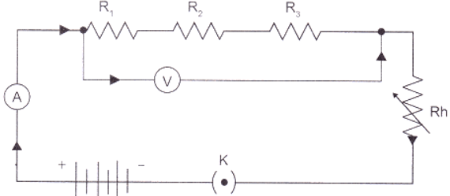  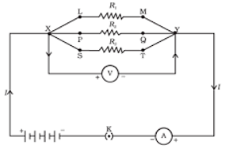  It showed an electric current in which 3 resistors having resistor R $​_{1}$ , R $​_{2}$ and R $​_{3}$ respectively are join end to end i.e series. While the combination of the resistor in which 3 resistors connected together which point X and Y are said to be parallel.  - The total potential difference across a combination of a resistor in series is equal to  - V$​_{1}$ + V $​_{2}$ + V $​_{3}$  - V$​_{1}$ - V $​_{2}$ +V $​_{2}$  - V$​_{1}$ + V $​_{2}$  - None of these  - In a series combination of resistor, the current is  - same at every point of the circuit  - different at every point of the circuit  - zero  - can not be determined  - The electrical energy disputed in the resistor is given by  - W = VIT  - W = VIR  - W = RIT  - W = RT  - If 5 resistor, each of value 0.2 ohm are connected in series what will be the resultant resistance  - 1 ohm  - 10 ohm  - 6 ohm  - 8 ohm  - The figure given below shows three resistors. 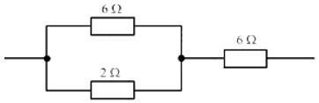  - Their combined resistance is:  - 16$Ω$  - 14$Ω$  - $\frac{20}{3}Ω$  - $\frac{15}{2}Ω$ | [4]
67 | Read the following and answer any four questions: For the flow of charge in a conductor metallic wire, gravity does not play any role. The electron moves only if there is a difference in electric potential. The difference of potential may be produced by a battery, consist of one or more electric cells. The chemical action with a cell generate the potential difference across the terminal of the cell, even when no current is drawn from it, potential difference set the charges in motion in the conductor produce an electric current, the cell has to expend its chemical energy stored in it.  - The potential difference between 2 points is measured as:  - V =$\frac{W}{Q}$  - V =$\frac{R}{I}$  - V =$\frac{Q}{I}$  - V = IR  - Keeping the potential difference constant, the resistance of the circuit is halved. The current will become:  - one - fouth  - four times  - half  - double  - The potential difference across the 3 - ohm resistance in the following diagram is: 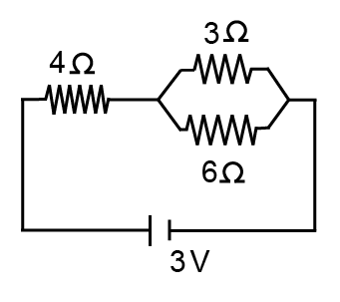  - $\frac{1}{9}$ V  - 3 V  - 2 V  - 1 V  - The other name of the potential difference is:  - amperage  - wattage  - voltage  - potential energy  - The S.I unit of electric potential difference is volt (V) named after:  - Alessandra volta  - Alandra volta  - Alessandra volt  - Alexandra volt | [4]
68 | Read the following and answer any four questions: Electric power is the rate of doing work or consumption of energy. Power is given by the rate at which electric energy is dissipated or consumed in an electric circuit. It is also term as electric power. The commercial unit of electric energy is kilo - watt - hours commonly known as a unit.  - The S.I unit of electric power is  - Volt  - Joule  - Watt  - Coulomb  - An electric heater is rated at 2 KW electrical energy cost 4 per kWh. What is the cost of using the heater  - $₹$ 12  - $₹$ 24  - $₹$ 36  - $₹$ 48  - Power may be given by  - P = VI  - P =$\frac{I^{2}}{R}$  - P =$\frac{V^{2}}{R}$  - all of these  - 1 Kilowatt is equal to  - 1000 watts  - 100 watts  - 10000 watts  - 10 watts  - An electric bulb is connected to a 220V generator. The current is 0.50 A, whatis the power of the bulb?  - 50W  - 110W  - 550W  - 220W | [4]
69 | Several resistors may be combined to form a network. The combination should have two end points to connect it with a battery or other circuit elements. When the resistances are connected in series, the current in each resistance is same but the potential difference is different in each resistor. When the resistances are connected in parallel, the voltage drop across each resistance is same but the current is different in each resistor.  - The two wires of each of resistance R, initially connected in series and then in parallel. In the graph it shows the resistance in series and in parallel. Which one iscorrect? 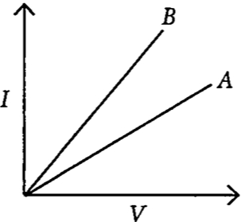  - The equivalent resistance of r$​_{1}$ and r $​_{2}$ , when connected in series is R $​_{1}$ and when they are connected in parallel is R $​_{2}$ . Then the ratio is  - The equivalent resistance between A and B is 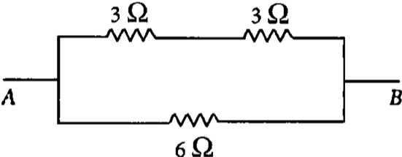  - OR  - Two resistances 10 $Ω$ and 3 $Ω$ are connected in parallel across a battery. If there is a current of 0.2 A in 10 $Ω$ resistor, the voltage supplied by battery is | [4]
70 | Read the Case study followed by 3 questions Part (i)and (ii) are compulsory. However, an internal choice has been provided in part (iii): The electrical energy consumed by an electrical appliance is given by the product of its power rating and the time for which it is used. The SI unit of electrical energy is Joule. Actually, Joule represents a very small quantity of energy and therefore it is inconvenient to use where a large quantity of energy is involved. So for commercial purposes, we use a bigger unit of electrical energy which is called kilowatt - hour. 1 kilowatt - hour is equal to 3.6 $×$ 10 $​^{6}$ joules of electrical energy.  - The energy dissipated by the heater is E. When the time of operating the heater is doubled, what would be the energy dissipated?  - The power of a lamp is 60 W. What will be the energy consumed in 1 minute?  - The electrical refrigerator rated 400 Woperates 8 hours a day. The cost of electrical energy is$₹$ 5per kWh. Find the cost of running the refrigerator for one day? OR Calculate the energy transformed by a 5 A current flowing through a resistor of 2 $Ω$ for 30 minutes? | [4]
71 | Read the Case study followed by 3 questions Part (i)and (ii) are compulsory. However, an internal choice has been provided in part (iii): The rate of flow of charge is called electric current. The SI unit of electric current is Ampere (A). The direction of flow of current is always opposite to the direction of flow of electrons in the current. The electric potential is defined as the amount of work done in bringing a unit positive test charge from infinity to a point in the electric field. The amount of work done in bringing a unit positive test charge from one point to another point in an electric field is defined as potential difference. $V_{AB}=V_{B}−V_{A}=\frac{W_{BA}}{q}$ The SI unit of potential and potential difference is volt.  - The 2 C of charge is flowing through a conductor in 100 ms, then what would be thecurrent in the circuit?  - What would be the potential difference between the two terminals of a battery, if 100 joules of work is required to transfer 20 coulombs of charge from one terminal of the battery to other?  - What is the number of electrons flowing per second in a conductor if 1 A current is passing through it?  - OR  - Write the formula of voltage in terms of work done, current, time and charge. | [4]
72 | Read the Case study followed by 3 questions Part (i)and (ii) are compulsory. However, an internal choice has been provided in part (iii): Two or more resistances are connected in series or in parallel or both, depending upon whether we want to increase or decrease the circuit resistance. 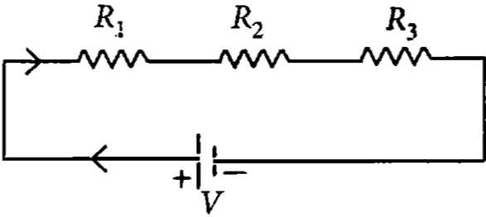  The two or more resistances are said to be connected in series if the current flowing through each resistor is the same. The equivalent resistance in the series combination is given by R $​_{S}$ = R $​_{1}$ + R $​_{2}$ + R $​_{3}$  - When the three resistors each of resistance R ohm are connected in series then what will be the equivalent resistance?  - There is a wire of length 20 cm and having resistance 20$Ω$ cut into 4 equal pieces and then joined in series. What is equivalent resistance?  - In the following circuit, find the equivalent resistance between A and B(R = 2$Ω$ )  - 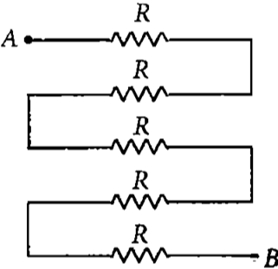  - OR  - In the given circuit, what is the current in each resistor?  - 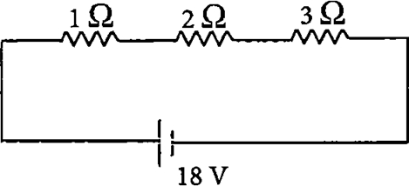 | [4]
73 | Read the Case study followed by 3 questions Part (i)and (ii) are compulsory. However, an internal choice has been provided in part (iii): The heating effect of current is obtained by transformation of electrical energy into heat energy. Just as mechanical energy used to overcome friction is covered into heat, in the same way, electrical energy is converted into heat energy when an electric current flows through a resistance wire. The heat produced in a conductor, when a current flows through it is found to depend directly on (a)strength of current (b) resistance of the conductor (c) time for which the current flows. The mathematical expression is given by H = I $​^{2}$ Rt. The electrical fuse, electrical heater, electric iron, electric geyser etc. all are based on the heating effect of current.  - What are the properties of heating element?  - What are the properties of electric fuse?  - When the current is doubled in a heating device and time is halved, what will be the heat energy produced? OR A fuse wire melts at 5 A. Itis desired that the fuse wire of same material melt at 10 A. Find thenew radius of the wire? | [4]
74 | Read the Case study followed by 3 questions Part (i)and (ii) are compulsory. However, an internal choice has been provided in part (iii): If two or more resistances are connected in such a way that the same potential difference gets applied to each of them, then they are said to be connected in parallel. 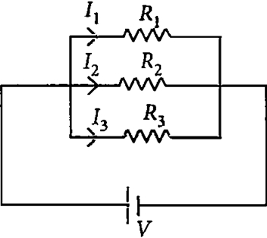  The current flowing through the two resistances in parallel is, however, not the same. When we have two or more resistances joined in parallel to one another, then the same current gets additional paths to flow and the overall resistance decreases. The equivalent resistance is given by $\frac{1}{R_{p}}=\frac{1}{R_{1}}+\frac{1}{R_{2}}+\frac{1}{R_{3}}$  - Three resistances, 2$Ω$ , 6 $Ω$ and 8 $Ω$ are connected in parallel, then what will be the equivalent resistance?  - A wire of resistance 12$Ω$ is cut into three equal pieces and then twisted their ends together, then what will be theequivalent resistance?  - Three resistances are connected as shown. The calculate the equivalent resistance between A and B? 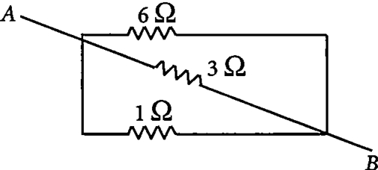  - OR  - Find the current in each resistance.  - 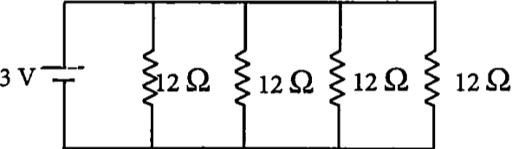 | [4]
75 | The obstruction offered by a conductor in the path of flow of current is called resistance. The SI unit of resistance is ohm ($Ω$ ). It has been found that the resistance of a conductor depends on the temperature of the conductor. As the temperature increases the resistance also increases. But the resistance of alloys like mangnin, constantan and nichrome is almost unaffected by temperature. The resistance of a conductor also depends on the length of conductor and the area of cross - section of the conductor. More be the length, more will be the resistance, more be the area of cross - section, lesser will be the resistance.  - Which of the following is not will desired in material being used for making electrical wires?  - The V - I graph for two metallic wires A and B is given. What is the correct relationship between their temperatures? 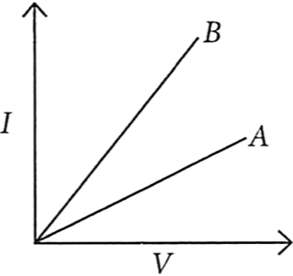  - Two wires of same material one of length L and area of cross - section A, other is of length 2L and area$\frac{A}{2}$ ,what is the relation between their resistance?  - OR  - A wire of resistance 20 $Ω$ is cut into 5 equal pieces. The resistance of each part is | [4]

